[](http://www.google.co.uk/url?sa=i&rct=j&q=&esrc=s&source=images&cd=&cad=rja&uact=8&docid=LFHuC0VY0_xV_M&tbnid=5TXmgFzi0juMbM:&ved=0CAUQjRw&url=http://craigmarloch.co.uk/news-events/dates-for-your-diary-2014/&ei=5J7oU6v8CuvG7AbSjICgDg&bvm=bv.72676100,d.ZGU&psig=AFQjCNGLVeJoRmO2V_nfSCCKsugI3YmFaw&ust=1407840131506705) COSTA

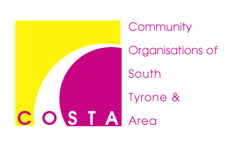

Community Organisations of South Tyrone & Areas

President Grants Homestead, 45 Dergenagh Road

Dungannon, Co Tyrone, BT70 1TW

Tel: 028 855 56880 Fax: 028 855 56881

**Email: info.costa@btconnect.com**

**Facebook: www.facebook.com/costa.network**

**Web: www.costaruralsupportnetwork.org**

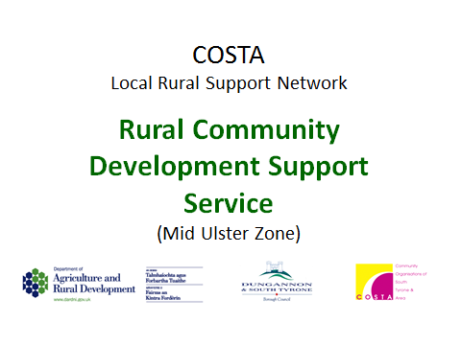**COSTA Rural Community Development Support Service**

New Mid Ulster District Council Logo**Upcoming Training & Information Workshops For People & Groups Mar 2020 – Mar 2021**

## **‘Planning & Running On-line Meetings & AGMs’ - (Helpful guidance during Covid-19 situation).**

## **‘Reopening Your Community Facility - A Practical Guide’ - (Practical Covid-19 guidance for Halls).**

## **‘Ltd Company Director Responsibilities During Covid-19’ - (Legal Requirements for Companies and Directors during Covid-19).**

1. **‘Charity Registration & Charity Annual Returns’ Information Workshop – Available to groups on request.** (Helpful guidance for the Charity Commission Registration process AND / OR the Annual Returns Process – ***practical assistance also available to all groups on request).***
2. **‘Good Governance, Committee Skills & Roles’ – particularly suitable for newer / grass roots groups and new Committees) *Available to groups on request.***
3. **‘Limited Company Governance & Director Responsibilities’ – Useful Updates on Legislation and requirements particularly suitable for Directors & Ltd Companies - *Available to groups on request.***
4. **‘Preparing for Sustainability’ Workshop –** *Available to groups on request.*Helpful guidance for groups and halls aiming for greater future sustainability.
5. **‘Introduction to Social Economy & Preparing to Tender’ Workshop –** *Available to groups on request.* For groups new to the public tendering process and how to start preparing for Tendering.
6. **‘Social Economy & Sustainability’ –** *Available to groups on request* ideal for groups to think about / plan for sustainability.
7. **‘Human Rights’ / ‘Human Rights Act (1998)’ –** Available to groups on request (suitable for all).
8. **‘Diversity Inclusion & Anti-Racism’ –** Available to groups on request suitable for all groups / orgs.
9. **‘Equality, Inclusion & Good / Community Relations’ –** *Available to groups on request* (suitable for all).

***Bespoke & other Sessions can also be offered – Contact COSTA any time!***

***Contact COSTA if your group would like any training / capacity building***

To book or express interest contact COSTA: Tel: 028 855 56880 or email: [info.costa@btconnect.com](mailto:info.costa@btconnect.com)

**COSTA is funded by**

Department of Agriculture, Environment & Rural Affairs (DAERA) through DAERA’s Rural Community Development Support Service (RCDSS)

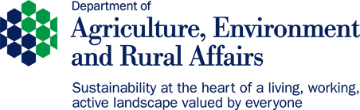New Mid Ulster District Council Logo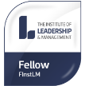Tackling Rural Poverty & Social Isolation Programme and Mid Ulster District Council *Registered Company in Northern Ireland No: NI 42832 Registered with the Charity Commission for Northern Ireland NIC101598*