Mid Ulster Community Planning
Community Panel Review
December 2019

Background

“The Local Government Act (NI) 2014 requires the council and its Community Planning partners to seek the views of the community, encourage them to express their views and take their views into account in the Community Planning process” (Statutory Guidance for the Operation of Community Planning Local Government Act, Northern Ireland, 2014)

The Community Plan states that “A community Panel will sit within the overall structure where 10 representatives elected from the community and voluntary sector across the district will advise on the delivery of the Community Plan and ensure that the views and the needs of the community are always at the centre of implementation and delivery. A larger process of Community Engagement will compliment this Panel”

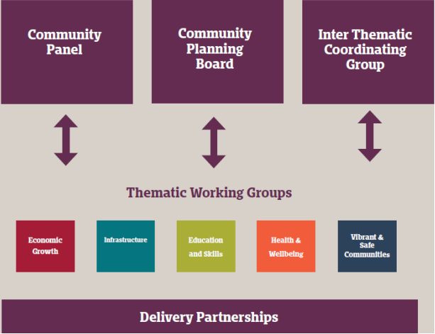

In adherence to the above, the Mid Ulster Community Panel was set up in 2017 as part of the establishment of a governance structure to oversee the delivery of the Mid Ulster Community Plan. To create the Community Panel Mid Ulster Community Planning facilitated a nomination and election process in three stages:

Stage 1: Group Registration. All community and voluntary groups based in the District were invited to register. All registered groups were then entitled to both nominate and vote in the process.

Stage 2: Group Nomination. A registered group was offered to nominate a member of their group for election to the Community Panel via an application form.

Stage 3: Election Process. A ballot form giving details of all the nominees, was issued to all registered groups. Groups were then asked to vote for up to 10 from the list of nominees. Registered groups that did not nominate anyone were still entitled to vote in the election.

The election process commenced in October 2016 and ended in February 2017 with the election of the 10 member Community Panel. The first meeting of the Community Panel took place on the next month on 15th March and Panel members attended the launch of the Community Plan on 2nd May which was followed by the first round of the thematic workshops, that afternoon.

Since then, Panel members have been participating in thematic workshops which has saw the development and publication of short term delivery plans in April 2018 along with continued delivery of Community Planning actions. One member of the Community Panel also represents at the Mid Ulster Community Planning Strategic Board.

In October 2018 Panel Members took part in an Inter-thematic Community Convention in the Burnavon, Cookstown. The purpose of the evening was to provide an update to the Community, Voluntary and Business sectors on the 10 year Community Plan and Short Term Delivery Plan 2017 – 2020. The agenda for the evening included an update on the Community Plan followed by three Thematic Presentations. The update was presented by a member of the Strategic Partnership Board and presentations by representatives from relevant partner agencies. When all formal presentations were complete, thematic workshops were held to provide more information to participants on actions within the Short Term Delivery Plan and exploration of how the community, voluntary and business sectors can contribute to the delivery of the plan. Feedback from attendees at the event was very positive about the content of the plan.

Community Panel Terms of Reference

The Community Panel operate in accordance with a Terms of Reference that lays out the roles and responsibilities of the Community Panel and its members:

- A community Panel will sit within the overall structure where 10 people from the community and voluntary sector across the District will guide on the delivery of the Community Plan and ensure that the views and the needs of the community sector in general are included in the development of the action planning and monitoring of delivery. A larger process of Community Engagement will compliment this Panel.
- Panel members will participate within the 5 thematic working groups and will provide the general views of the wider community. Meetings will take place during the day.

- Panel members will participate in quarterly Panel meetings to discuss issues arising from the thematic groups and take wider community views forward to meetings. Meetings will take place during the day.

- Panel members will co-design and participate at the CVS Conventions with Mid Ulster District Council (MUDC) Officers to ensure the wider community is aware of community plan development and delivery.

- Panel members will provide the wider community issues both general and thematic within the community planning process and not individual areas or organisation agendas.

- Panel members will participate in meetings relevant to Community Planning, as and when they can. There is no financial contribution for this and therefore if any location cannot be attended, the Community Planning Coordinator can link in comments and feedback.

- Panel members will have due regard for confidentiality of the Community Panel proceedings.

- Any member who fails to attend three consecutive Community Panel meetings without reasonable explanation may be asked to withdraw their place and allow a suitable replacement to be recruited.

- Membership of the Panel will be reviewed every 2 years (2017-2019).

- The Community Panel has no legal structure. Members will operate on an advisory/guidance capacity to the Community Planning working groups, providing the views of the wider community and voluntary sector.

The Terms of Reference also addresses the role of the Mid Ulster Council Community Planning Coordinator in providing administrative support to the Community Panel and its members. This includes,

- Issuing all Panel meeting papers 5 days in advance of meetings.

- Record all meetings.

- Collate, distribute and coordinate follow ups on actions.

- Provide a meeting venue for all Panel meetings. Meetings will be rotated between Cookstown, Dungannon and Magherafelt.

- Provide refreshments at meetings. A light lunch will be provided for all members if meetings take place over a lunch period.
Community Panel Review

As per the Mid Ulster Community Panel Terms of Reference, A review of the Community Panel and its membership was carried out. This review commenced in December 2019 and was due to be completed in early 2020. However, the COVID19 pandemic had caused the publication of the review’s findings and recommendations to be postponed until now. The review of the Community Panel consisted of the following process:

- Feedback from Panel Members on their participation in the delivery of Community Planning in Mid Ulster through questionnaire and focus group.

Member Questionnaires were received from 3 Panel Members. A focus group also took place with 6 Panel Members, using the questions from the questionnaire.

Members found their participation in Community Planning positive. Many see the benefit to organisations working together to achieve better outcomes for the people of Mid Ulster. “My brain is Mid Ulster. If I can affect change in areas such as education or transport, I think it is very positive”

Several found the work at the thematic groups relevant to the work they are involved in, in the community and voluntary sector. “Yes, it does have quite a lot of direct relevance to what we do as it links back to themes of tackling poverty”

All members felt however, that they were limited in their participation at thematic workshops, as they tended to be “dominated” by the representatives from the statutory agencies. “I can’t see where a community voice fits in a thematic group”. Many expressed their preference to discuss Community Planning issues and delivery, at the Community Panel meetings instead. “The Community Panel is a better forum to express our views”

While members strived to represent the views of the community and voluntary sector at the thematic workshops, they once again felt that they were limited in their efforts, due to the priorities of the statutory partners taking precedence. However, members underlined the value of the large scale consultation that took place to develop the Community Plan and agreed the Plan was a good reflection of the needs of the people in Mid Ulster District Council area.

Members thought there was a greater need for wider community engagement and that the 10 person panel was possibly too small to promote Community Planning throughout the district. Some members noted that it was difficult to fully engage with the promotion of Community Planning throughout the district, as they were only volunteering in this role and they had several other commitments. All the members found the newsletter produced by the Community Planning Coordinator a useful resource to promote Community Planning and stated for this to be continued on a regular basis.

- Review of Panel member’s attendance to Thematic Group Workshops and Community Panel Meetings as per Term of Reference.

The majority of members had over 70% attendance at the Community Panel meetings. 3 members attended less than 50% of the Community Panel meetings.

3 members attended more than 70% of their scheduled thematic workshops. 4 members attended less that 40% of their thematic workshops. The average attendance of all members to the thematic workshops was 45%.

The difference in Community Panel Member’s attendance to the thematic workshops and the Community Panel meetings, provides further evidence to the difficulties they experienced in participating at thematic groups and their preference to discussing relevant community Planning issues and delivery at the Community Panel meetings.

- Analysis of other Community Planning community & voluntary sector engagement structures across NI.

The Community Planning Coordinator had previously carried out desk based research on Community Planning community & voluntary sector engagement structures across NI in preparation for the publication of the review in early 2020. However, a more detailed review was recently published in September 2020 by Community Places, on behalf of Carnegie Trust, entitled “Representation of Community and voluntary sector in Community Planning”. As a result, it was decided to use the information within this report to inform the Community Panel review (See Appendix A). The resource paper outlines a range of models which are used across the 5 jurisdictions of the UK and Ireland. The models being applied across the jurisdictions can be viewed as falling into six types:

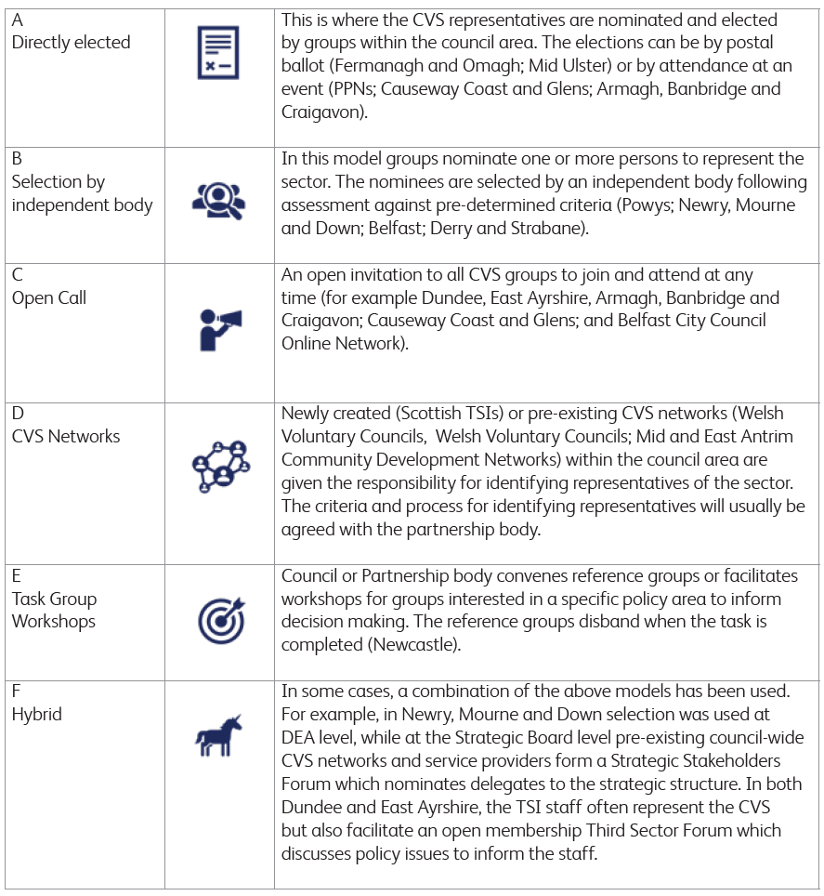

A workshop was held on 25th August 2020 involving partners from across the community planning spectrum, where participants reviewed the findings from the report on all the various Community Planning engagement structures used across the UK and Ireland and discussed which models, they thought worked best. The majority of participants preferred the Open Call model (40%) followed by CVS Networks (38%), Task Group Workshops (36%) and Hybrid Model (36%). Interestingly, the directly elected model, which Mid Ulster have, was less supported (10%).

- Recommendations for future Community Panel structure and membership.

The contribution of the community and voluntary sector is paramount to the development and delivery of Community Planning, to improve the lives and achieve better outcomes for the people of Mid Ulster. The intention of the Community Panel was to be a vehicle in which Community Planning could engage with the wider CVS across Mid Ulster and vice versa. However, this has been difficult. Community Panel members have voiced their disappointment at being unable to contribute better at thematic workshops, which they felt, were dominated by statutory partners. How much they have been able to contribute to informing the wider community on Community Planning and its outcomes has also been limited. However, Community Panel members have underlined the benefits they found in discussions within the Community Panel meetings, where they feel they are able to discuss openly and contribute more fully to Community Planning.

In light of the information gathered, it is proposed to set up the following Community & Voluntary structure within Mid Ulster:

DEA Community Fora
- 7 DEA community consultative/engagement forums
- Invites through Expression of Interests sent to all CVS groups on Council database within each DEA geography
- 1 – 2 meetings per year
- Forum to update/inform CVS of any project/programme/grant etc being delivered by Council or CP partner
- CVS consultative/engagement body for council and statutory partners
- Networking opportunities for groups
- CVS can raise issues, which we directed to appropriate service for action
- Will provide the structure to engage and deliver strategic programmes such as new RDP & Peace Plus and Council grants

Strategic CVS Network
- Invite to following strategic CVS organisations: Rural Network Rep, Mid Ulster Disability Forum, Mid Ulster LGBT Group, STEP, Women’s Group Rep, Mid Ulster Carers Network, Mid Ulster Youth Forum, Mid Ulster Seniors Network, Loneliness Network, Community Transport Rep, Shopmobility, Volunteer Centre
- 2 meetings per year
- Forum to update/inform CVS of any project/programme/grant etc being delivered by Council or CP partner
- CVS consultative/engagement body for council and statutory partners
- Networking opportunities for groups

Community Planning Thematic Group Representation
Direct representation model – partners are identified as per relevancy to thematic group and invited to participate

